

To:
The Honorable Senator Bob Menendez
Chairman, Senate Foreign Relations Committee
The Honorable Senator Jim Risch
Ranking Member, Senate Foreign Relations Committee

The Honorable Senator Jack Reed
Chairman, Senate Armed Services Committee
The Honorable Senator James Inhofe
Ranking Member, Senate Armed Services Committee
May 13, 2022

Dear Congressional Leaders:

We write to you today to discuss the difficult issue of Turkey in light of the crisis in Ukraine. This is particularly true in light of the coming meeting between Secretary of State Anthony Blinken and Turkish Foreign Minister Mevlut Cavusoglu, and in light of reports that the Administration has recently communicated to Congress that it supports the sale of some advanced F-16 equipment to Turkey.
While the crisis in Ukraine is dire, Turkey remains a bad actor. Thus, concerns with Ankara must be addressed. Congress should insist that any transaction with Turkey not harm either America’s vital interests nor values.

As you know, Turkey is being sanctioned under Countering America's Adversaries Through Sanctions Act (CAATSA), as well as facing other punitive measures, including removal from the F-35 program, due to the purchase of S-400 missiles from Russia. This is inconsistent with its membership in NATO, and which present direct security challenges when co-located with sensitive American military equipment. Turkey steadfastly refuses to reverse course on the S-400 missile, or address other US and NATO concerns.

The Middle East Forum, along with other allied organizations, has publicly raised concerns about the sale of advanced F-16s or upgrade kits. This is partly due to the fact that, as with the F-35, co-location of such advanced equipment with S-400s is a danger to American security, and also because Turkey has become an authoritarian state with strong sympathies for Islamists under President Recep Tayyip Erdoğan. This is the opposite of what Turkey stood for until he took power in 2003.

Moreover, Erdogan’s sympathy for Islamism means that Turkey is now one of the most dangerous purveyors of a toxic Islamist ideology in the world. Erdoğan’s Turkey, to quote two scholars, is “drawing new fault lines across the region—pitting statist, secular, republican governance models against the culturally-expansionist, militant, and pan-Islamist alternative in Turkey.”
Previously, Turkish behavior, concerning the S-400 missile, the record on human rights, fanning the flames of conflict in Syria, Armenia, Libya, and so on, had earned Erdoğan a cold shoulder from Congress. Indeed, dozens of members of Congress have stated clearly that they oppose advanced military equipment sales due to such concerns.
Yet, one cannot ignore the crisis in Ukraine, nor Turkey’s importance to the conflict. This fact has caused some in Congress to allow the possibility of supporting Turkey’s aims on advanced F-16’s.
Acknowledging both the situation in Ukraine and the nature of Erdoğan’s Turkey, Congress should insist that the Administration:

- Cease funding jihadi terrorist organizations in Syria and hosting terrorist groups such as Hamas
- Actively support Ukraine and not equally assist Russia
- Ensure Russia cannot use Turkey’s banks to evade sanctions
- Ensure that no sensitive American equipment from advanced F-16’s is co-located with S-400 missiles
- And any additional actions that may deter Turkish misbehavior

Every effort should be made to ensure that the Republic of Turkey acts according to America’s interests and values, even while we take into account the vital stakes in the Ukraine/Russia conflict.
Sincerely,
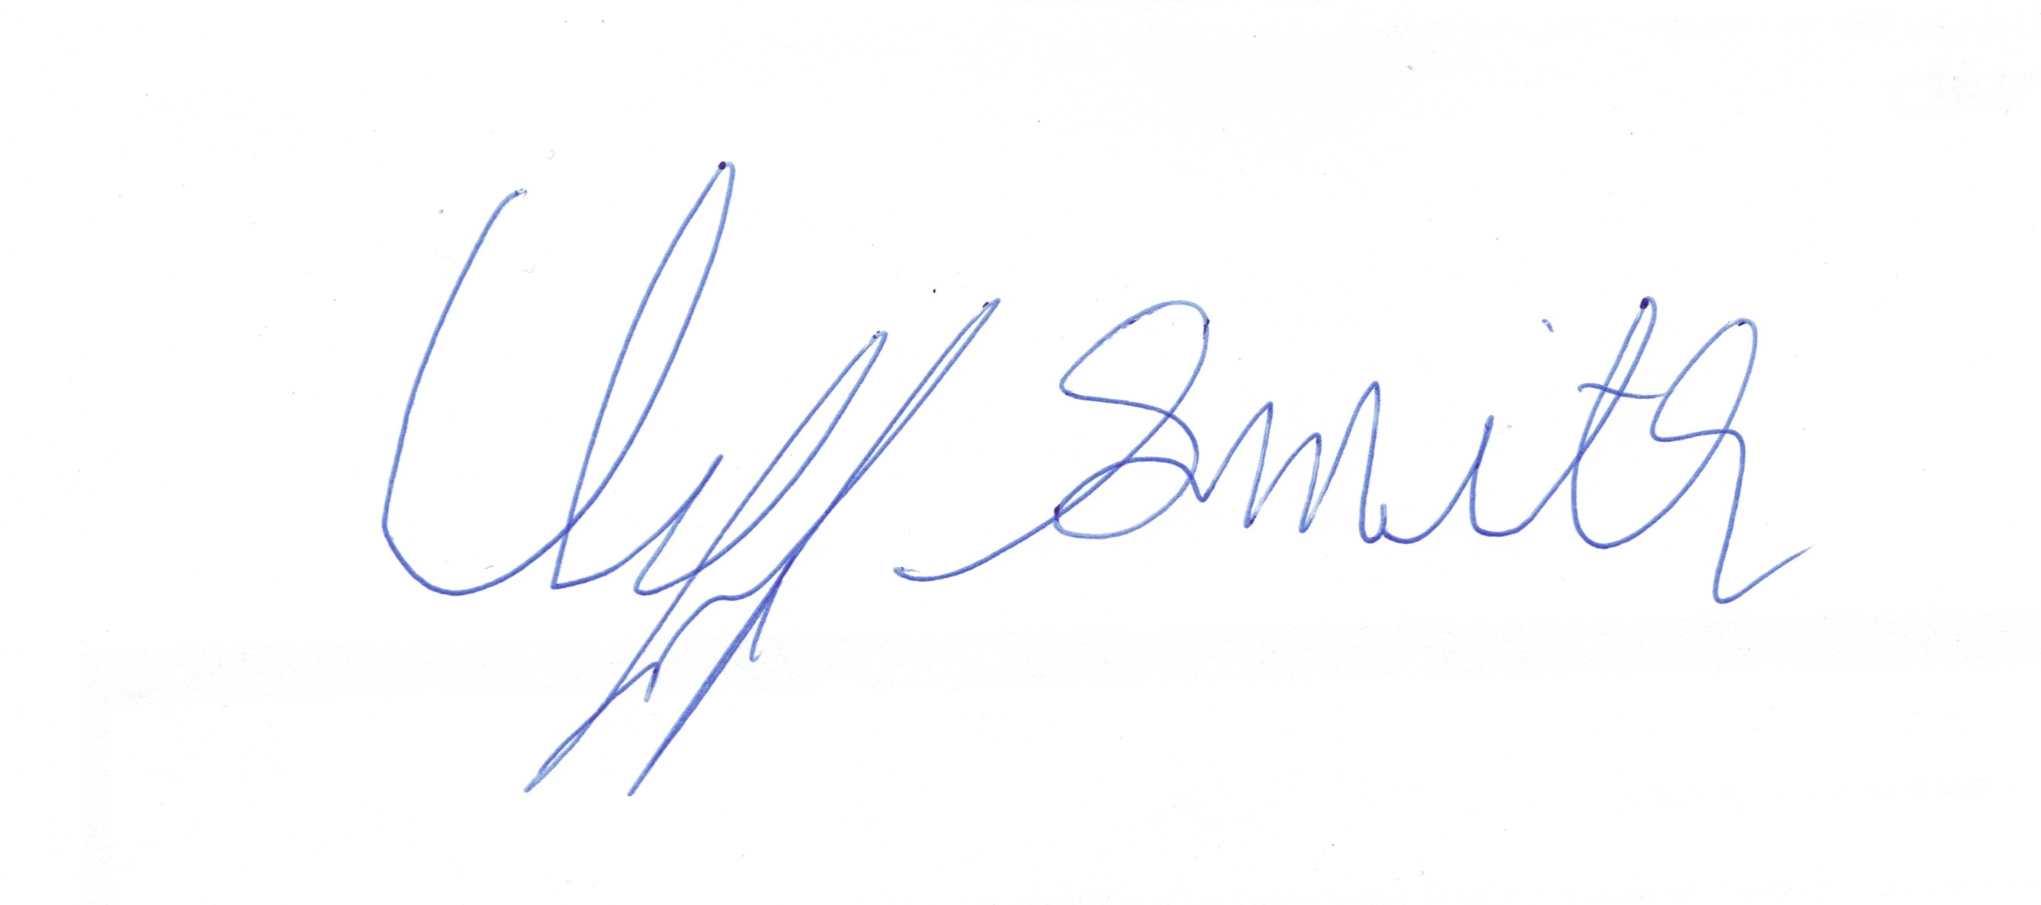
Clifford V. Smith
Washington Project Director
Middle East Forum

"Turkey’s Cavusoglu says Blinken invited him to Washington for talks on May 18," May, 2022, Ekathimerini.com. Available at: https://www.ekathimerini.com/news/1181726/turkeys-cavusoglu-says-blinken-invited-him-to-washington-for-talks-on-may-18/
"Biden Administration Asks Congress to Approve New Weapons Deal With Turkey," By: Jared Malsin, May 11, 2022. Available at: https://www.wsj.com/articles/biden-administration-asks-congress-to-approve-new-weapons-deal-with-turkey-11652262674
"Turkey officially kicked out of F-35 program, costing US half a billion dollars," By: Aaron Mehta, Defense News, July 19, 2019. Available at: https://www.defensenews.com/air/2019/07/17/turkey-officially-kicked-out-of-f-35-program/
"U.S. and Turkey in close touch on S-400/F-35 dispute: NATO commander," By: Andrea Shalal, June 18, 2019, Reuters. Available at: https://www.reuters.com/article/us-france-airshow-usa-turkey/u-s-and-turkey-in-close-touch-on-s-400-f-35-dispute-nato-commander-idUSKCN1TJ0VX
"Turkey’s Dangerous New Exports: Pan-Islamist, Neo-Ottoman Visions and Regional Instability," By: Marwa Maziad, Jake Sotiriadis, April 21, 2020, Middle East Institute. Available at: https://www.mei.edu/publications/turkeys-dangerous-new-exports-pan-islamist-neo-ottoman-visions-and-regional
"Pallone Leads Bipartisan Call to Biden Administration Urging Rejection of F-16 Fighter Jet Sale to Turkey," Feb. 4, 2022, Press Release. Available at: https://pallone.house.gov/media/press-releases/pallone-leads-bipartisan-call-biden-administration-urging-rejection-f-16
"Congress signals openness to Turkey F-16 sale amid Ukraine cooperation," By: Bryan Harris, May 4, 2022, Defense News. Available at: https://www.defensenews.com/congress/2022/05/04/congress-signals-openness-to-turkey-f-16-sale-amid-ukraine-cooperation/

